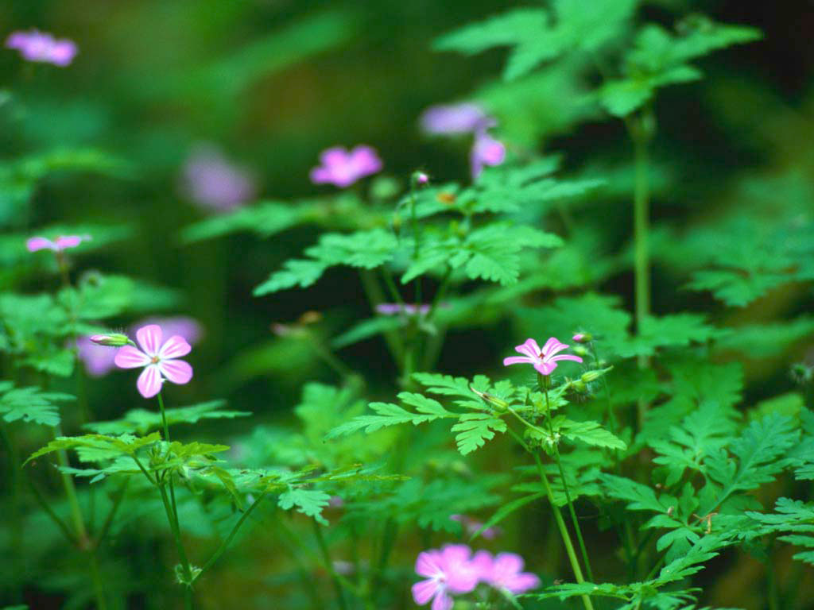

PLANT SALE

HISTORIC CONGREGATION B’NAI ABRAHAM

527 LOMBARD STREET
SUNDAY MAY 6 - NOON TO 5 PM

FLOWERS FOR YOUR HOME and GARDEN
Herbs, tomatoes, flowering plants, and more!

HELP SUPPORT HISTORIC CONGREGATION B’NAI ABRAHAM
Rain or shine
